HOME FOR SALE
WALTON COUNTY SPECIAL!

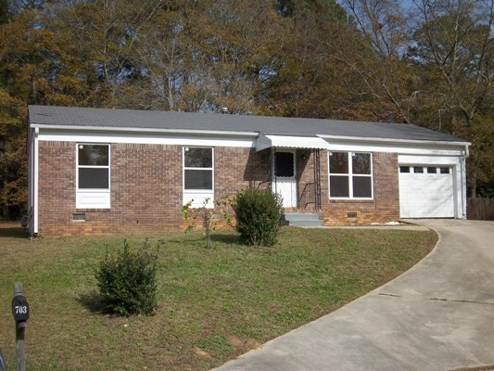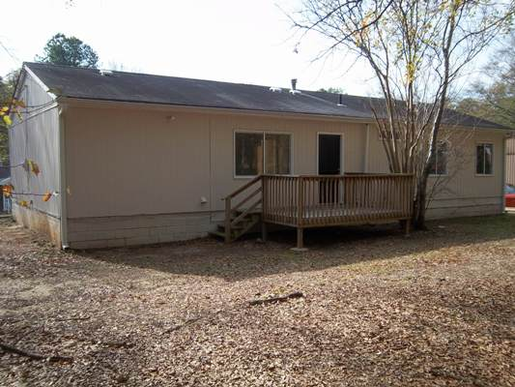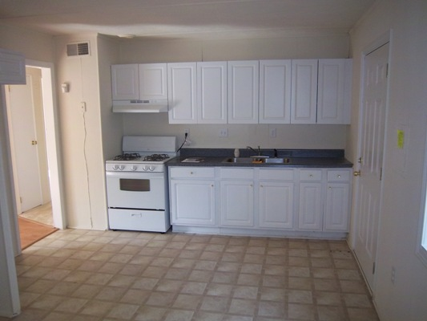

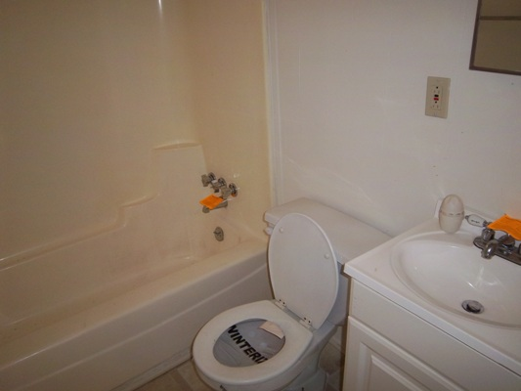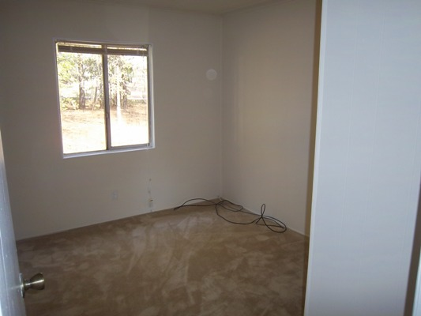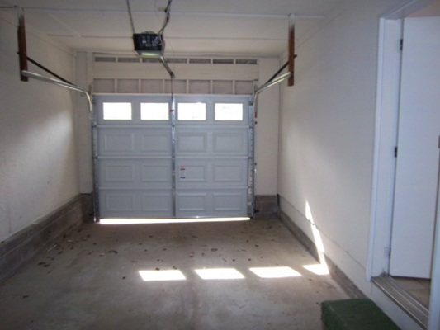

$22,700 cash/hard money

Priced Low For Quick Sale!

703 Kendall Court

Monroe, GA 30655
WALTON COUNTY
Great Low Walton County Taxes!

This is a cute brick front ranch located in a very quiet neighborhood in the city of Monroe.

This home offers 4 (small) bedrooms with 1 full baths and has been renovated!!
- Only thing the house needs is an outside a/c unit, a small fridge, some blinds and a little landscaping and it’s ready to rent. Total rehab less than $2k
- Tax value of $50,000 with low annual property taxes of only $615 per year! This will significantly help you cash flow! The home last sold for $63,200 on 06/28/06. The neighborhood will easily afford market rents of $600 per month maybe even a little more because of the 4 bedrooms. With the low taxes your return on investment should be close to 25% per year!

Contact: Kevin Morice @ 678-427-7700 Owner

www.ThisGreatHouse.com

LOCKBOX CODE A M N

