Rent To Own
Cedar Siding Ranch!!
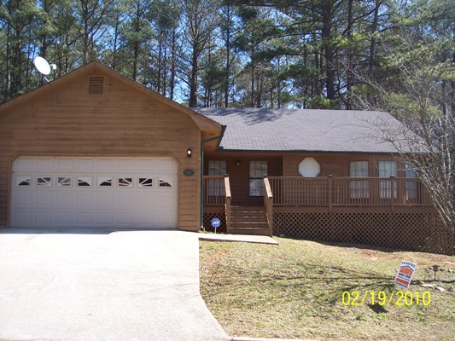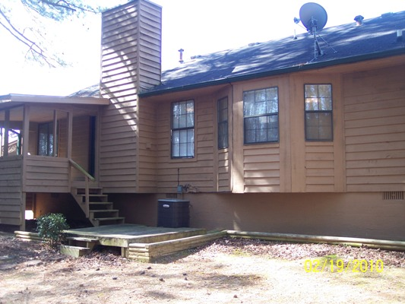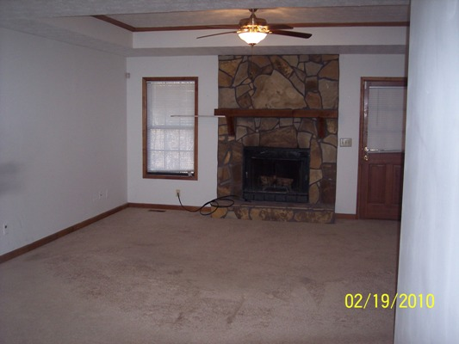

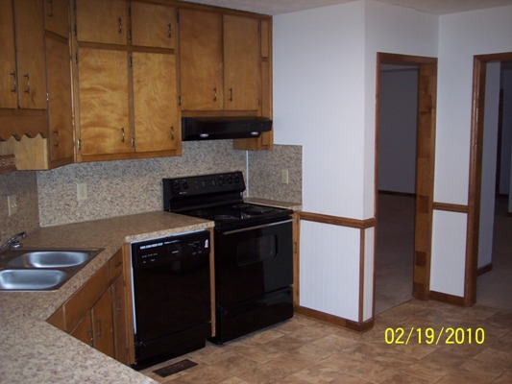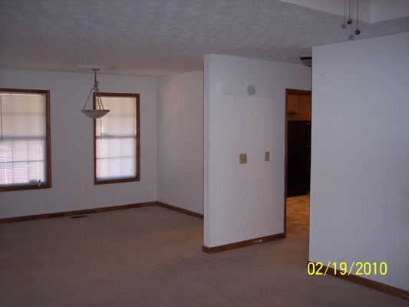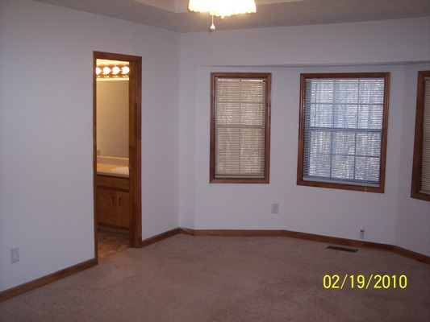

$80,000

Great House!

644 Pepperwood Lane

Stone Mountain, GA 30083
DEKALB COUNTY
Nice Subdivision/Great Location!!

Cedar wood siding ranch home with 2 car garage built in 1986 that has been recently updated. Home also offers a covered back porch and private back yard and is located in a very nice subdivision!.

This home offers 3BR and 2BA split bedroom plan with 1608’ of living space. Very large eat-in kitchen and formal dining room.
- Following is recent updates done to the house: new 25 year roof, interior and exterior paint, newer carpet, newer light fixtures, kitchen updates including newer appliances and new counter tops.
- This home qualifies for our rent to own program. Put down a $1500 option fee/down payment which all goes towards the price of the house and monthly rent amount of only $825! Our program also includes rent credits towards purchase price up to $200 per month making your net rent only $625.

Contact: Kevin Morice @ 678-427-7700 Owner

www.ThisGreatHouse.com

