HOME FOR RENT
Lease-To-Own

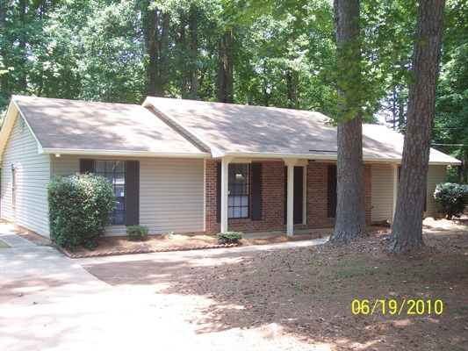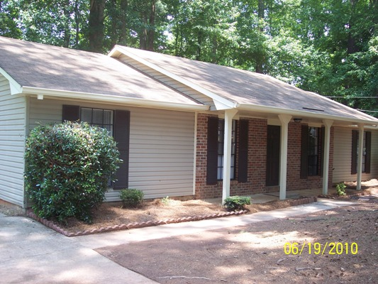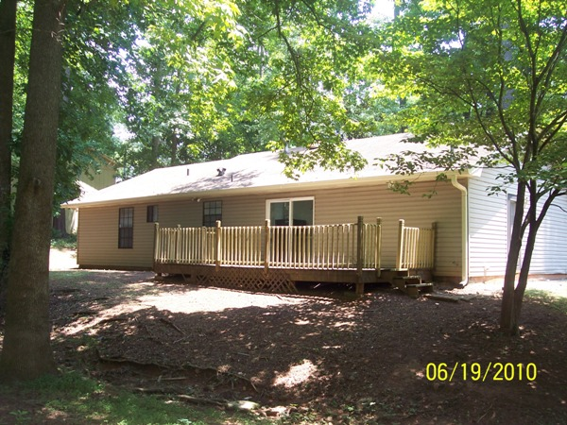

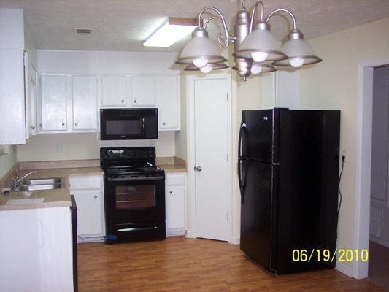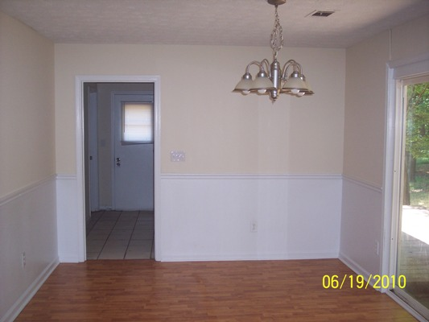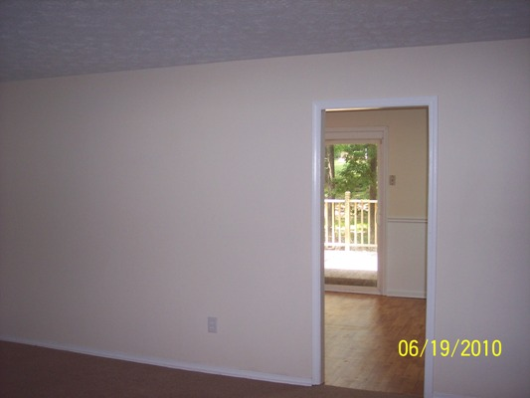

$69,900 Sales Price
$750 / Month

SECTION 8 OK! 5890 Marbut Road SECTION 8 OK!

Lithonia, GA 30058
DEKALB COUNTY

This is a brick and vinyl siding ranch style home that has been recently renovated! The house sits on a level private lot and is located in a very convenient area of Lithonia.

The home offers 4 bedrooms with 2 baths and is in overall very good shape! Recent upgrades include new kitchen cabinets, new counter tops, all new appliances including a refrigerator, beautiful hardwood floors throughout living area and kitchen, all new mechanicals including hot water heater and HVAC system.

Owner willing to consider owner finance or lease option with option fee/down payment. A portion of monthly rent would go towards sales price of the house. Lease option requirement would be $1500 down which all goes towards the purchase price, $750 per month of which $200 would also go towards the purchase price. Normal down payment for owner financing is 10%.

Contact: Kevin Morice @ 678-427-7700

www.ThisGreatHouse.com

Call for lockbox code or to receive an application!

