HOME FOR RENT
Lease Option/Owner Finance!

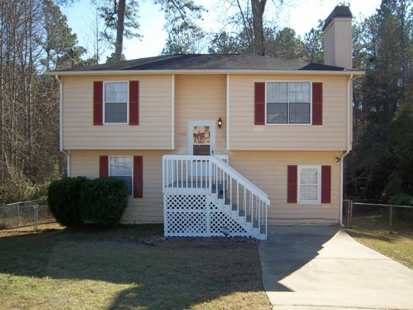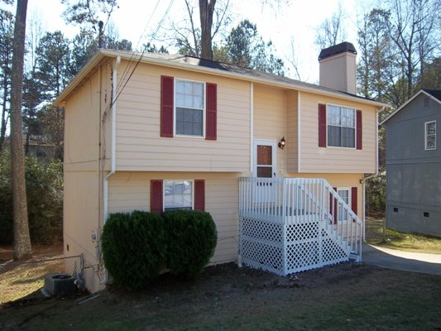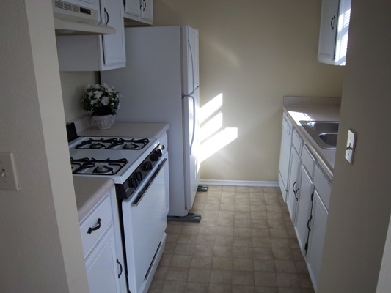

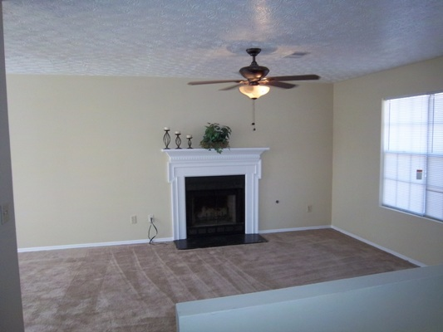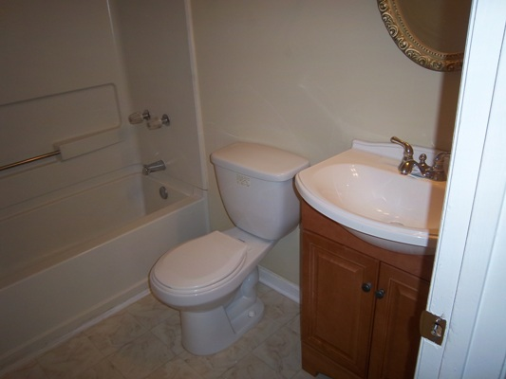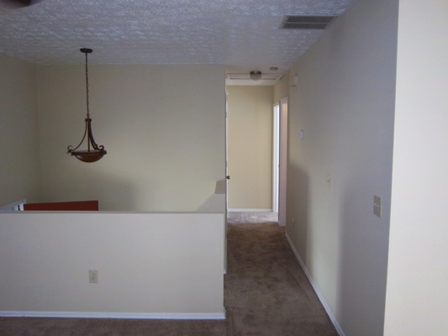

$800 per month

Priced Low For Quick Sale!

5580 Downs Way

Lithonia, GA 30058
DEKALB COUNTY
Renovated!

This is a siding split foyer built in 1989 that has been recently renovated. It is gorgeous inside with fresh paint, new fixtures and new flooring!

This home offers 4 bedrooms with 2 full baths and includes over 1400’ of living space!
- Monthly rent of $800 with $500 security deposit. Lease Option available with $1500 option fee towards purchase price of $59,900 with $100 monthly credit towards purchase price.

Contact: Kevin Morice @ 678-427-7700 Owner

www.ThisGreatHouse.com

