OWNER FINANCE
Handyman Special
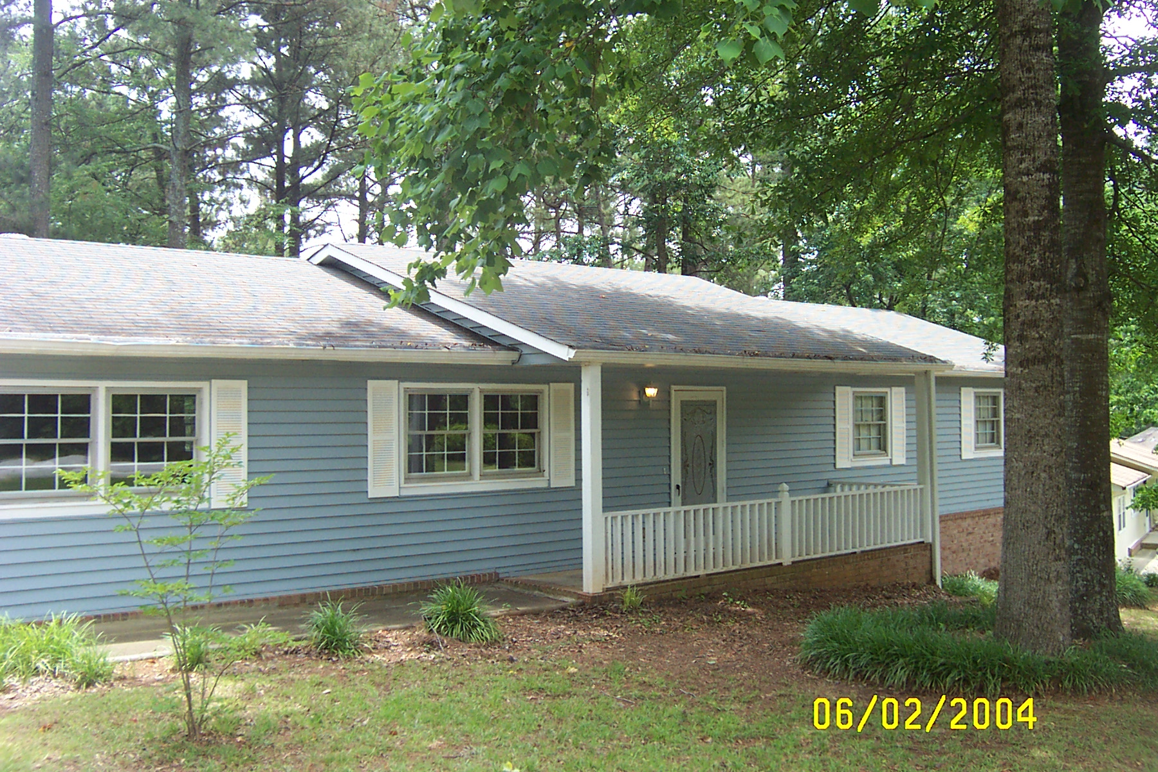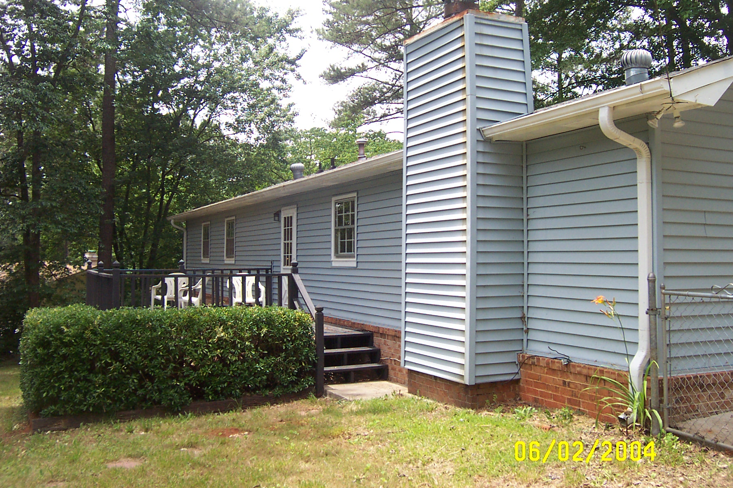

$98,000

ANNISTOWN RIDGE

4908 Spirit Court

Stone Mountain, GA 30087
Hurry and take advantage of this great deal before the free grant money goes away!

- Vacant Vinyl Siding and Brick Ranch in need of some simple TLC, carpet, paint, sheetrock repair and new gutters!
- Home has 3 bedrooms and 2 full baths. Master bath has shower, and tile floor.
- Spacious updated eat-in kitchen with refinished cabinets, new light fixtures and newer appliances. Deck off Kitchen overlooks wooded, fenced-in backyard.
- Huge Great Room or Bonus Room finished with Brick Fireplace and ceiling fan.
- Home sits on an extra large corner lot.

Schools: Shiloh Elementary Shiloh Middle Shiloh High

Contact: Kevin Morice @ 678-427-7700 Owner

First Time Home Buyers may use the free $8000 tax credit as down payment and get into this house with nothing down. Monthly principle and interest payments less than $700 per month and you own the home!!

