HOME FOR RENT
Lease-To-Own

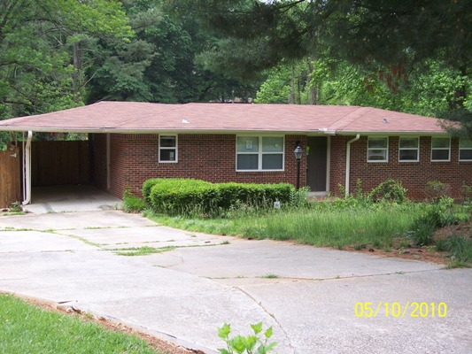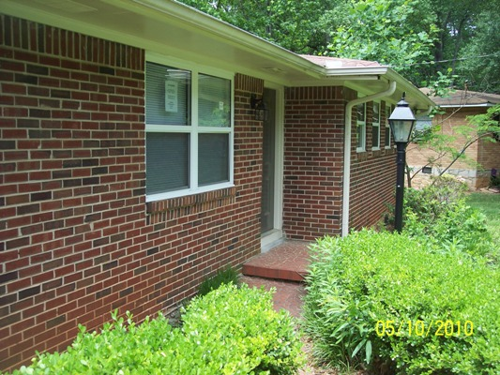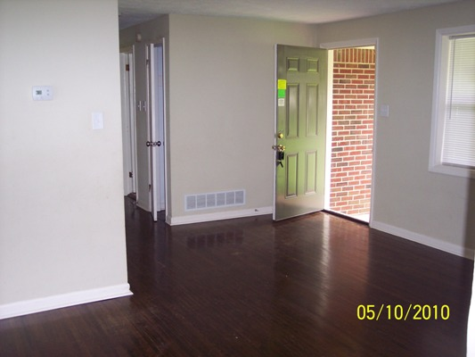

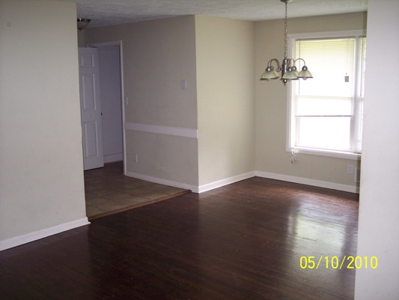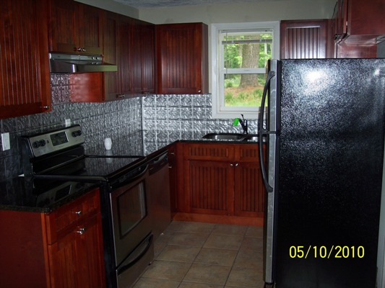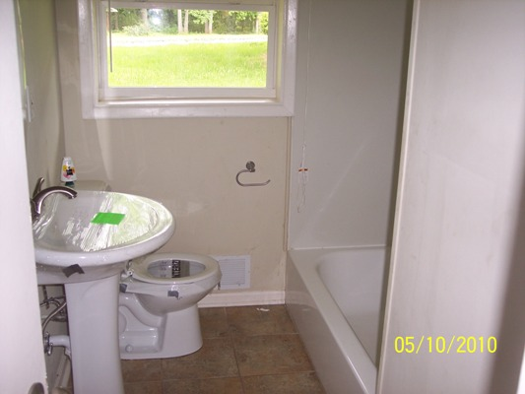

$74,900 Sales Price
$825 / Month

3577 Brookfield Lane

Decatur, GA 30032
DEKALB COUNTY

This is an all brick ranch style home built in 1958! The house sits on a level cul de sac lot in a great area of Decatur. Huge back yard that is fenced in!

This home offers 3 bedrooms with 1.5 baths and is in overall very good shape! The home has been recently upgraded including new kitchen cabinets, granite counter tops, all new stainless appliances including a refrigerator, beautiful hardwood floors throughout, updated bathrooms and upgraded light fixtures.

Owner willing to consider owner finance or lease option with option fee/down payment. A portion of monthly rent would go towards sales price of the house.

Contact: Kevin Morice @ 678-427-7700

www.ThisGreatHouse.com

Call for lockbox code or to receive an application!

