HOME FOR SALE
Lease-To-Own

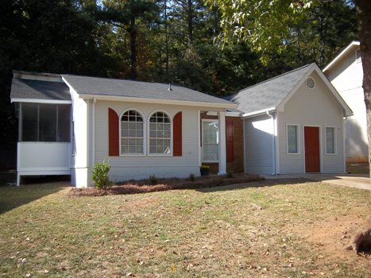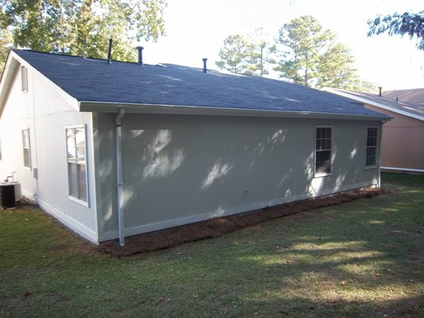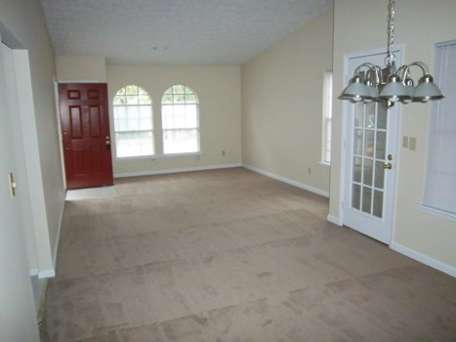

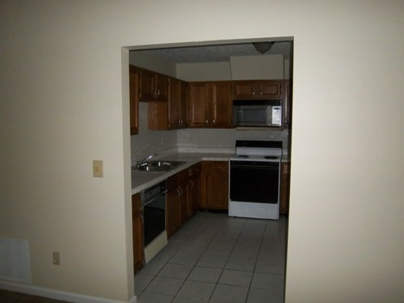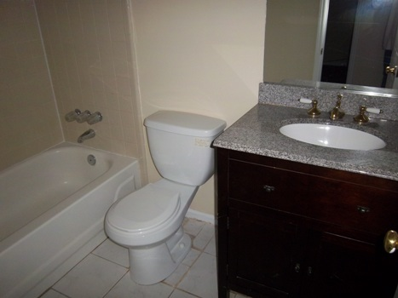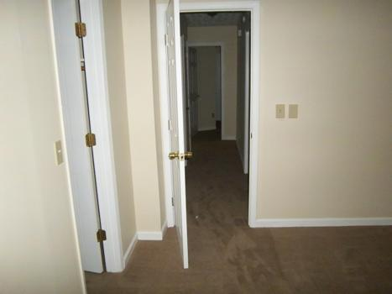

$69,900 Sales Price
$795 / Month

1947 Marbut Forest Drive

Lithonia, GA 30058
DEKALB COUNTY

This is a cute ranch style home with bonus room that has been recently renovated! The home is located in a nice subdivision very close to Covington Hwy right off Marbut Rd.

The home offers 3 bedrooms with 2 baths and a screen porch! Recent upgrades include beautiful neutral color plush carpets, tile in bathrooms and kitchen, new light fixtures including ceiling fans, freshly painted inside and out. All new appliances on order and scheduled for delivery upon executed contract.

Owner willing to consider owner finance or lease option with a small option fee/down payment. A portion of monthly rent would go towards sales price of the house. Lease option requirement would be $1500 down which all goes towards the purchase price, $795 per month of which $100 would also go towards the purchase price. Normal down payment for owner financing is 10%.

Contact: Kevin Morice @ 678-427-7700
www.ThisGreatHouse.com

Call for lockbox code or to receive an application!

