HOME FOR SALE
Lease-To-Own

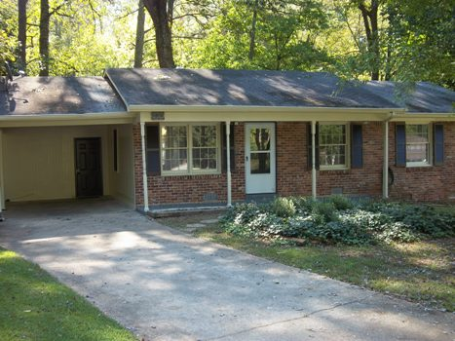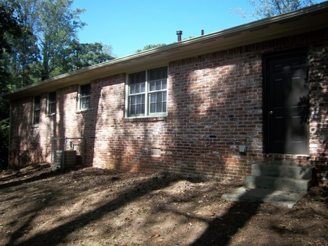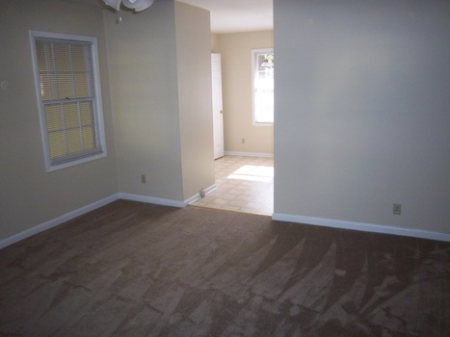

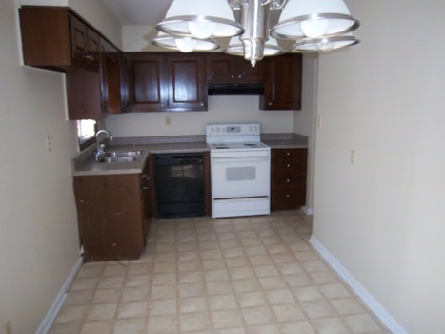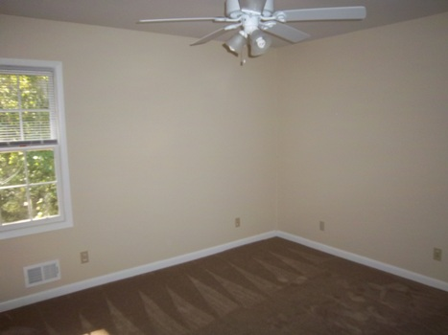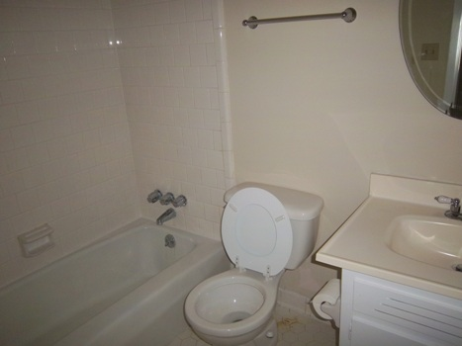

$74,900 Sales Price
$795 / Month

1514 Malibu Court

Decatur, GA 30032
DEKALB COUNTY

This is an all brick ranch style home with carport that has been recently renovated! The house sits on a level, private, cul-de-sac lot and is located in a very convenient area of Decatur. Very close to Covington Hwy and I-285.

The home offers 3 bedrooms with 2 baths and is in overall very good shape! Recent upgrades include newer appliances including a refrigerator, beautiful neutral color plush carpets, tile in bathrooms and freshly painted inside and out. All bedrooms have ceiling fans to help with utility bills.

Owner willing to consider owner finance or lease option with option fee/down payment. A portion of monthly rent would go towards sales price of the house. Lease option requirement would be $1500 down which all goes towards the purchase price, $795 per month of which $200 would also go towards the purchase price. Normal down payment for owner financing is 10%.

Contact: Kevin Morice @ 678-427-7700
www.ThisGreatHouse.com

Call for lockbox code or to receive an application!

