Home For Sale/Rent
BROOKWOOD SCHOOLS!

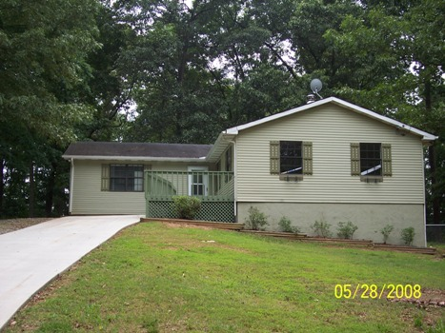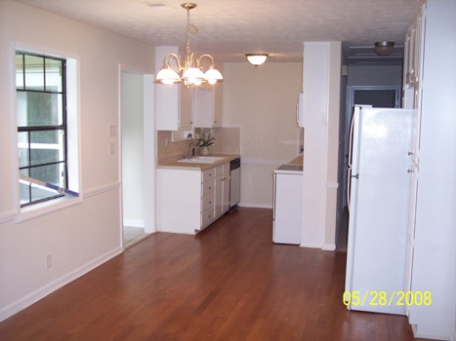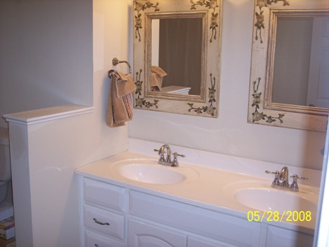

$104,900 reduced

11 Bagwell Way

Lawrenceville, GA 30044
GREAT LAWRENCEVILLE NEIGHBORHOOD!

- Picture Perfect 3 BR / 2 BA Ranch style home with unfinished basement ready for immediate occupancy!
- This home sits on a gorgeous ½ acre private lot!
- Home recently painted inside and out and offers new tile flooring, hardwood flooring in kitchen and new neutral plush carpeting throughout.
- Lovely Master Suite with large master bath and huge walk-in closet.

New Schools: Gwin Oaks Elem. Five Forks Middle Brookwood High

Contact: Kevin Morice @ 678-427-7700 or 678-662-4719

www.ThisGreatHouse.com

** Owner Finance or Rent to Own available on this home with small down payment and monthly rent amount of $850 per month. Rent credits may apply!

**Straight rental available at $850 per month with $500 security deposit.

